**Fog Computing**

Fog Computing is the term coined by Cisco that refers to extending cloud computing to an edge of the enterprise’s network. Thus, it is also known as Edge Computing or Fogging. It facilitates the operation of computing, storage, and networking services between end devices and computing data centers.

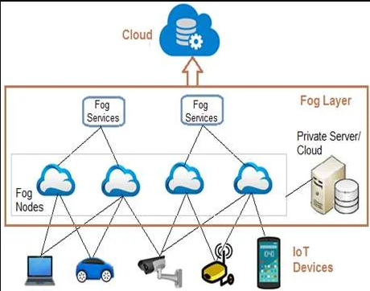

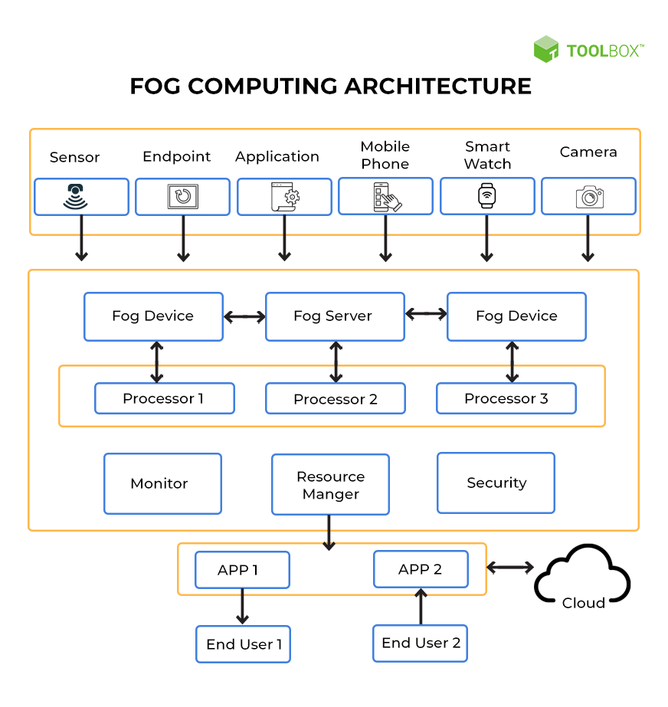

 The devices comprising the fog infrastructure are known as fog nodes.

1. In fog computing, all the storage capabilities, computation capabilities, data along with the applications are placed between the cloud and the physical host.
2. All these functionalities are placed more towards the host. This makes processing faster as it is done almost at the place where data is created.
3. It improves the efficiency of the system and is also used to ensure increased security.

**History of fog computing**

The term fog computing was coined by Cisco in January 2014. This was because fog is referred to as clouds that are close to the ground in the same way fog computing was related to the nodes which are present near the nodes somewhere in between the host and the cloud. It was intended to bring the computational capabilities of the system close to the host machine. After this gained a little popularity, IBM, in 2015, coined a similar term called “Edge Computing”.

**When to use fog computing?**   
Fog Computing can be used in the following scenarios:

1. It is used when only selected data is required to send to the cloud. This selected data is chosen for long-term storage and is less frequently accessed by the host.
2. It is used when the data should be analyzed within a fraction of seconds i.e. Latency should be low.
3. It is used whenever a large number of services need to be provided over a large area at different geographical locations.
4. Devices that are subjected to rigorous computations and processings must use fog computing.
5. Real-world examples where fog computing is used are in IoT devices (eg. Car-to-Car Consortium, Europe), Devices with Sensors, Cameras (IIoT-Industrial Internet of Things), etc.

**Advantages of fog computing**

* This approach reduces the amount of data that needs to be sent to the cloud.
* Since the distance to be traveled by the data is reduced, it results in saving network bandwidth.
* Reduces the response time of the system.
* It improves the overall security of the system as the data resides close to the host.
* It provides better privacy as industries can perform analysis on their data locally.

**Disadvantages of fog computing**

* Congestion may occur between the host and the fog node due to increased traffic (heavy data flow).
* Power consumption increases when another layer is placed between the host and the cloud.
* Scheduling tasks between host and fog nodes along with fog nodes and the cloud is difficult.
* Data management becomes tedious as along with the data stored and computed, the transmission of data involves encryption-decryption too which in turn release data.

**Applications of fog computing**

* It can be used to monitor and analyze the patients’ condition. In case of emergency, doctors can be alerted.
* It can be used for real-time rail monitoring as for high-speed trains we want as little latency as possible.
* It can be used for gas and oils pipeline optimization. It generates a huge amount of data and it is inefficient to store all data into the cloud for analysis.

**Basic Components of Fog Computing**

There are multiple ways of implementing a fog computing system. The common components across these architectures are explained below.

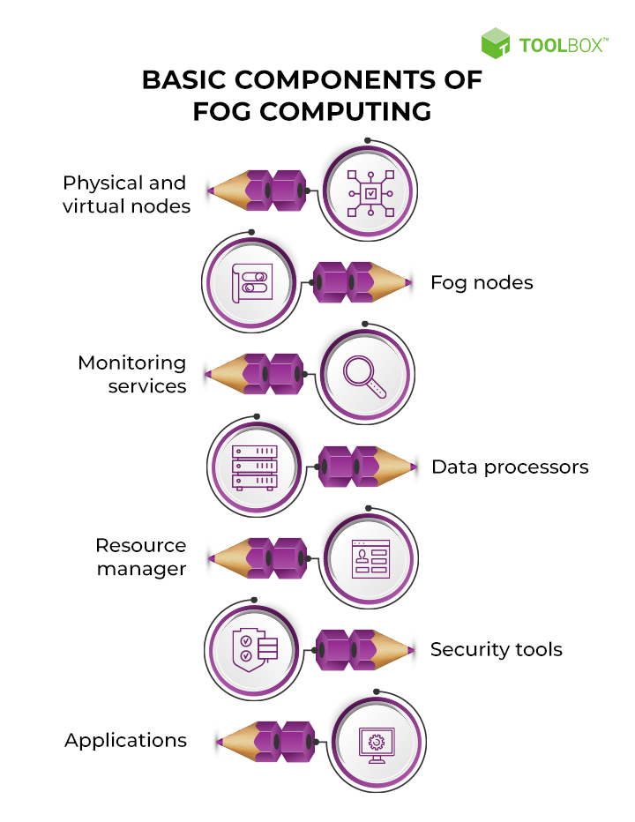

**1. Physical & virtual nodes (end devices):** End devices serve as the points of contact to the real world, be it application servers, edge routers, end devices such as mobile phones and smartwatches, or sensors. These devices are data generators and can span a large spectrum of technology. This means they may have varying storage and processing capacities and different underlying software and hardware.

**2. Fog nodes:** Fog nodes are independent devices that pick up the generated information. Fog nodes fall under three categories: fog devices, fog servers, and gateways. These devices store necessary data while fog servers also compute this data to decide the course of action. Fog devices are usually linked to fog servers. Fog gateways redirect the information between the various fog devices and servers. This layer is important because it governs the speed of processing and the flow of information. Setting up fog nodes requires knowledge of varied hardware configurations, the devices they directly control, and [network](https://www.spiceworks.com/tech/networking/what-is-a-computer-network/) connectivity.

**3. Monitoring services:** Monitoring services usually include application programming interfaces (APIs) that keep track of the system’s performance and resource availability. Monitoring systems ensure that all end devices and fog nodes are up and communication isn’t stalled. Sometimes, waiting for a node to free up may be more expensive than hitting the cloud server. The monitor takes care of such scenarios. Monitors can be used to audit the current system and predict future resource requirements based on usage.

**4. Data processors:** Data processors are programs that run on fog nodes. They filter, trim, and sometimes even reconstruct faulty data that flows from end devices. Data processors are in charge of deciding what to do with the data — whether it should be stored locally on a fog server or sent for long-term storage in the cloud. Information from varied sources is homogenized for easy transportation and communication by these processors. This is done by exposing a uniform and programmable interface to the other components in the system. Some processors are intelligent enough to fill the information based on historical data if one or more sensors fail. This prevents any kind of application failure.

**5. Resource manager:** Fog computing consists of independent nodes that must work in a synchronized manner. The resource manager allocates and deallocates resources to various nodes and schedules data transfer between nodes and the cloud. It also takes care of [data backup](https://www.spiceworks.com/it-security/cloud-security/articles/cloud-data-protection-backup/), ensuring zero data loss. Since fog components take up some of the SLA commitments of the cloud, high availability is a must. The resource manager works with the monitor to determine when and where the demand is high. This ensures that there is no redundancy of data as well as fog servers.

**6. Security tools:** Since fog components directly interact with raw data sources, security must be built into the system even at the ground level. [Encryption](https://www.spiceworks.com/it-security/network-security/articles/what-is-endpoint-encryption/) is a must since all communication tends to happen over wireless networks. End users directly ask the fog nodes for data in some cases. As such, user and access management is part of the security efforts in fog computing.

**7. Applications:** Applications provide actual services to end-users. They use the data provided by the fog computing system to provide quality service while ensuring cost-effectiveness. It is important to note that these components must be governed by an abstraction layer that exposes a common interface and a common set of protocols for communication. This is usually achieved using web services such as APIs.

**Examples and Use Cases of Fog Computing**

While cloud computing has become all-pervasive, fog computing is just coming up to address the various latency issues that plague [IoT devices](https://www.spiceworks.com/tech/iot/articles/what-is-ailing-iot-at-scale/).

**1. Smart homes:** One of the most common fog computing use cases is a smart home. A smart home consists of a technology-controlled ventilation and heating system such as the Nest Learning Thermostat, smart lighting, programmable shades and sprinklers, smart intercom systems to communicate with people indoors as well as those at the door, and an intelligent alarm system. Fog computing can be used to create a personalized alarm system. It can also be used to automate certain events, such as turning on water sprinklers based on time and temperature.

**2. Smart cities:** Smart cities aspire to be automated at every front, from garbage collection to traffic management. Fog computing is particularly pertinent when it comes to traffic regulation. Sensors are set up at traffic signals and road barriers for detecting pedestrians, cyclists, and vehicles. Speedometers can measure how fast they are traveling and how likely it can result in a collision. These sensors use wireless and [cellular technology](https://www.spiceworks.com/tech/innovation/articles/how-edge-and-5g-can-unlock-the-true-potential-of-ar-and-vr/) to collate this data. Traffic signals automatically turn red or stay green for a longer time based on the information processed from these sensors.

**3. Video surveillance:** The most prevalent example of fog computing is perhaps video surveillance, given that continuous streams of videos are large and cumbersome to transfer across networks. The nature of the involved data results in latency problems and network challenges. Costs also tend to be high for storing media content. Video surveillance is used in malls and other large public areas and has also been implemented in the streets of numerous communities. Fog nodes can detect anomalies in crowd patterns and automatically alert authorities if they notice violence in the footage.

**4. Healthcare:** The healthcare industry is one of the most governed industries, with regulations such as HIPAA being mandatory for hospitals and healthcare providers. This sector is always looking to innovate and address emergencies in real-time, such as a drop in vitals. One way of doing it is using data from wearables, blood glucose monitors, and other health apps to look for signs of bodily distress. This data should not face any latency issues as even a few seconds of delay can make a huge difference in a critical situation, such as a stroke.

**5. Others:** Other industries that use fog computing include retail, oil & gas, government & military, and hospitality. Personal assistants such as Siri and Alexa are available across devices and are compatible with most, such as smartwatches. This flexibility and presence mean that we can count on fog computing to become a crucial part of various industry verticals. Any enterprise that offers real-time solutions will need to incorporate fog computing into its existing [cloud infrastructure](https://www.spiceworks.com/tech/cloud/articles/what-is-cloud-computing-architecture-front-end-back-end-explained/).

**Difference Between Cloud Computing and Fog Computing**

**Cloud Computing:** The delivery of on-demand computing services is known as cloud computing. We can use applications to storage and processing power over the internet. It is a pay as you go service. Without owning any computing infrastructure or any data centers, anyone can rent access to anything from applications to storage from a cloud service provider.  
We can avoid the complexity of owning and maintaining infrastructure by using cloud computing services and pay for what we use. In turn, cloud computing services providers can benefit from significant economies of scale by delivering the same services to a wide range of customers.

**Fog Computing:** Fog computing is a decentralized computing infrastructure or process in which computing resources are located between the data source and the cloud or any other data center. Fog computing is a paradigm that provides services to user requests at the edge networks. The devices at the fog layer usually perform operations related to networking such as routers, gateways, bridges, and hubs. Researchers envision these devices to be capable of performing both computational and networking operations, simultaneously. Although these devices are resource-constrained compared to the cloud servers, the geological spread and the decentralized nature help in offering reliable services with coverage over a wide area. Fog computing is the physical location of the devices, which are much closer to the users than the cloud servers.

| **Feature** | **Cloud Computing** | **Fog Computing** |
| --- | --- | --- |
| Latency | Cloud computing has high latency compared to fog computing | Fog computing has low latency |
| Capacity | Cloud Computing does not provide any reduction in data while sending or transforming data | Fog Computing reduces the amount of data sent to cloud computing. |
|  |  |  |
| Responsiveness | Response time of the system is low. | Response time of the system is high. |
| Security | Cloud computing has less security compared to Fog Computing | Fog computing has high Security. |
| Speed | Access speed is high depending on the VM connectivity. | High even more compared to Cloud Computing. |
| Data Integration | Multiple data sources can be integrated. | Multiple Data sources and devices can be integrated. |
| Mobility | In cloud computing mobility is Limited. | Mobility is supported in fog computing. |
| Location Awareness | Partially Supported in Cloud computing. | Supported in fog computing. |
| Number of Server Nodes | Cloud computing has Few number of server nodes. | Fog computing has Large number of server nodes. |
| Geographical Distribution | It is centralized. | It is decentralized and distributed. |
| Location of service | Services provided within the internet. | Services provided at the edge of the local network. |
| Working environment | Specific data center building with air conditioning systems | Outdoor (streets,base stations, etc.) or indoor (houses, cafes, etc.) |
| Communication mode | IP network | Wireless communication: WLAN, WiFi, 3G, 4G, ZigBee, etc. or wired communication (part of the IP networks) |
| Dependence on the quality of core network | Requires strong network core. | Can also work in Weak network core. |